Ulvi Bajarani

SID 20539914

CSCI 6345 – Advanced Computer Networks

Summer II

Assignment 7

Creating the Security Groups in Windows Server 2019, sharing the files to the Groups and accessing to the files.

1) To distinguish our users and groups, the Organizational Unit with name **ForLab** is created. (This step might be skipped):

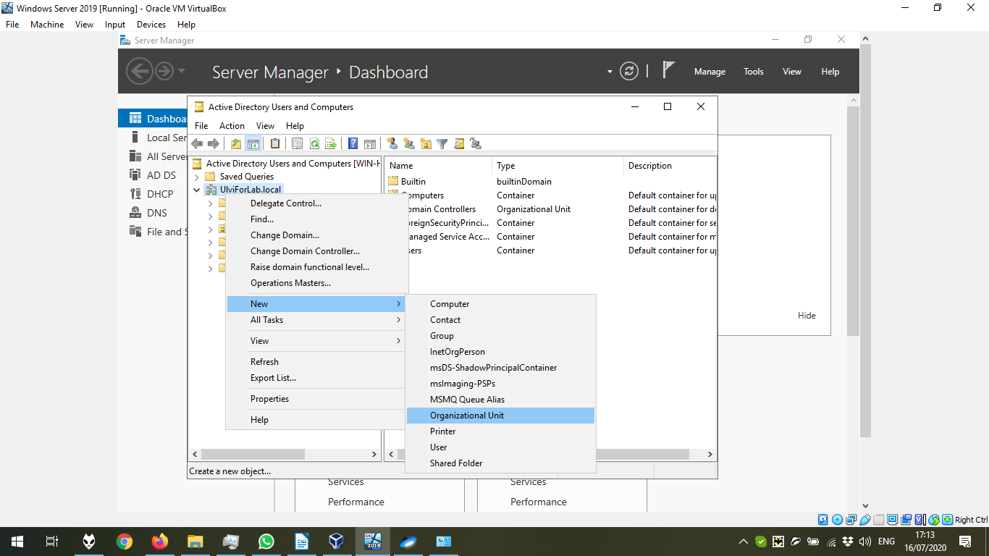

Giving the name for the Organizational Unit:

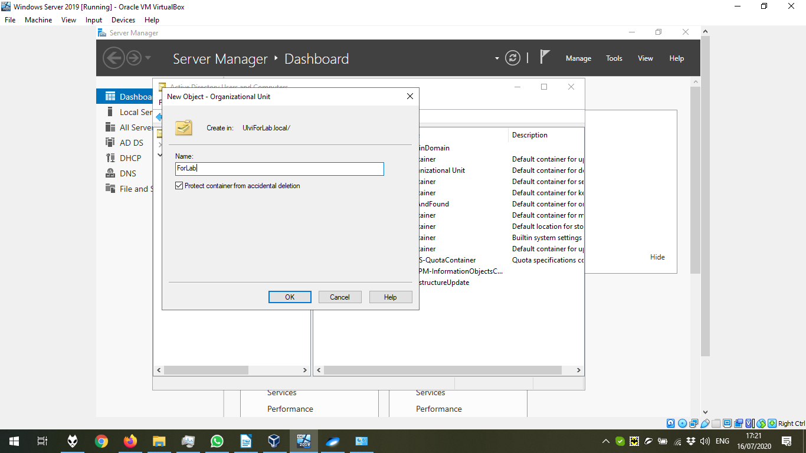

2) Now, let’s create the security groups inside our OU:

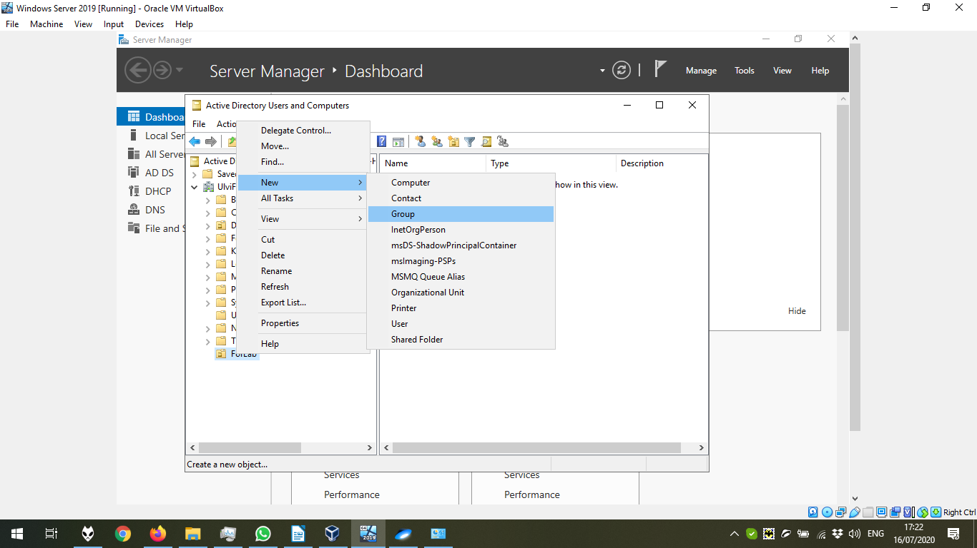

Giving the name to the security group:

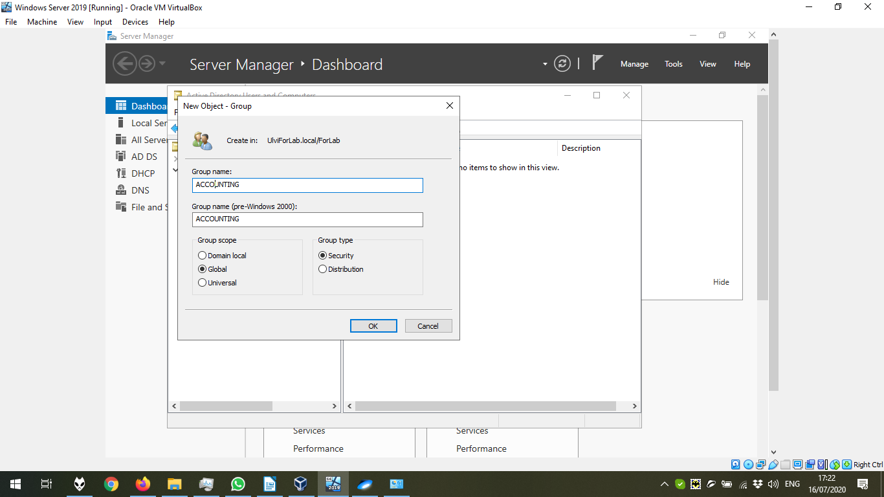

After creating all User Groups (**ACCOUNTING, FACULTY, STUDENTS**):

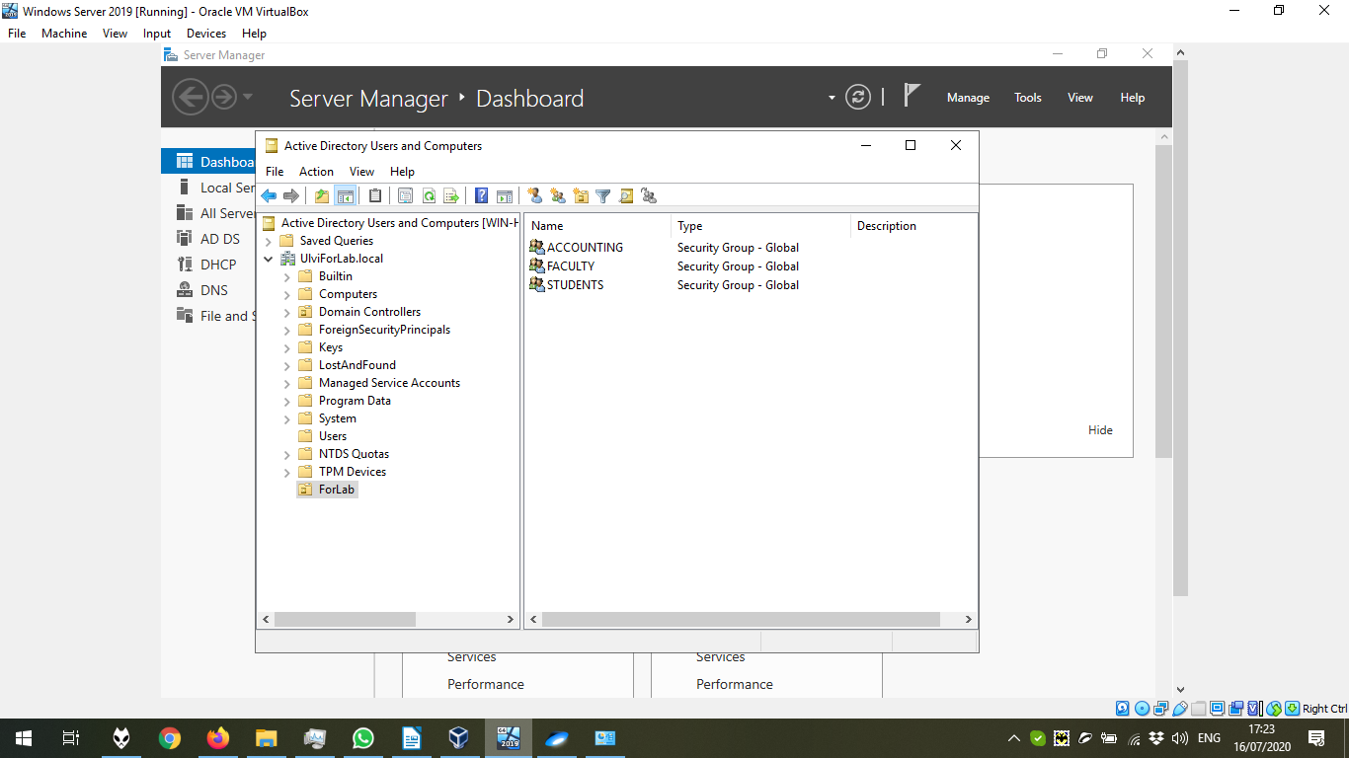

3) Let’s create users:

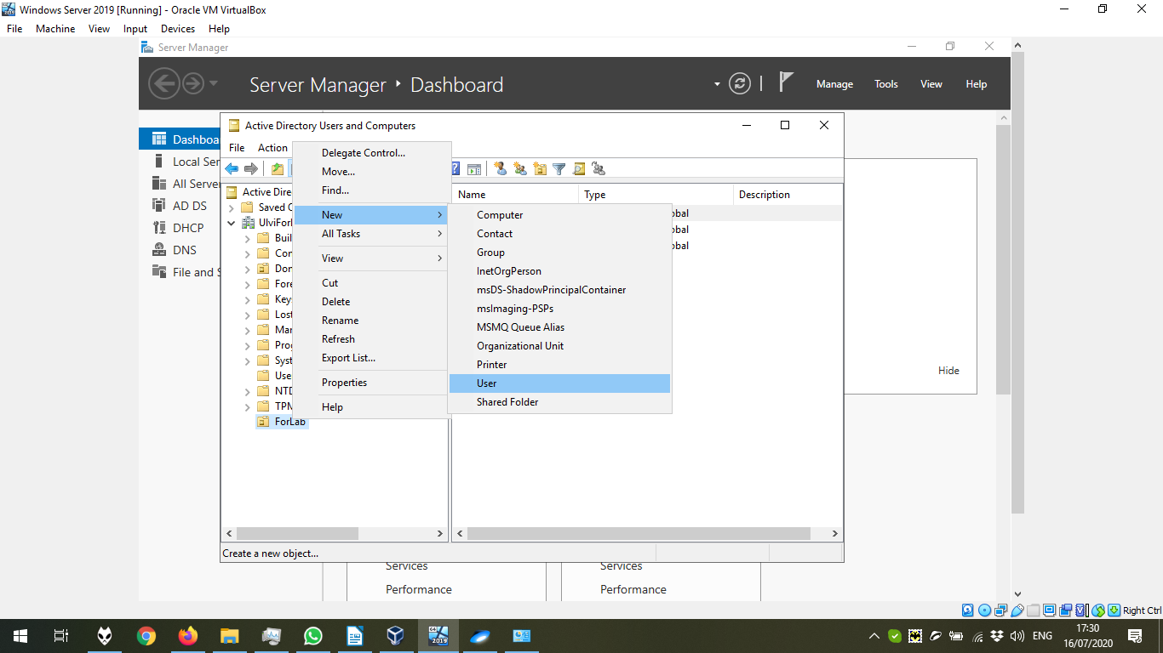

Creating the user:

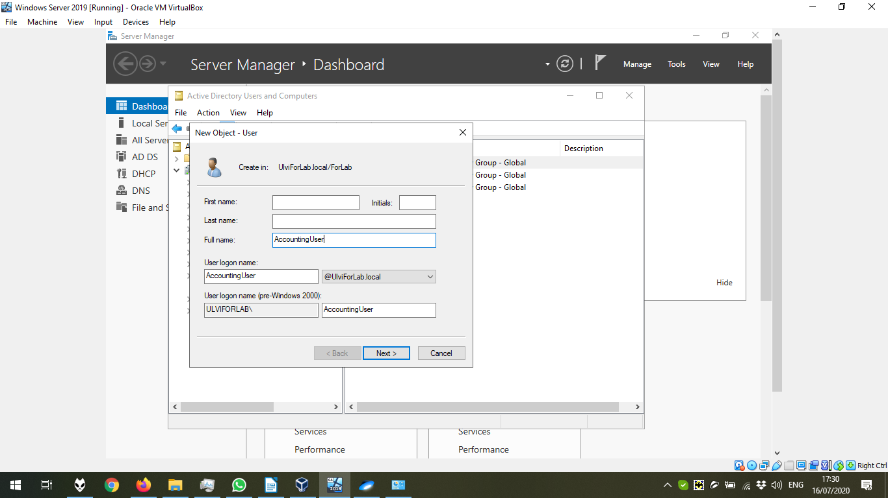

Setting the Password:

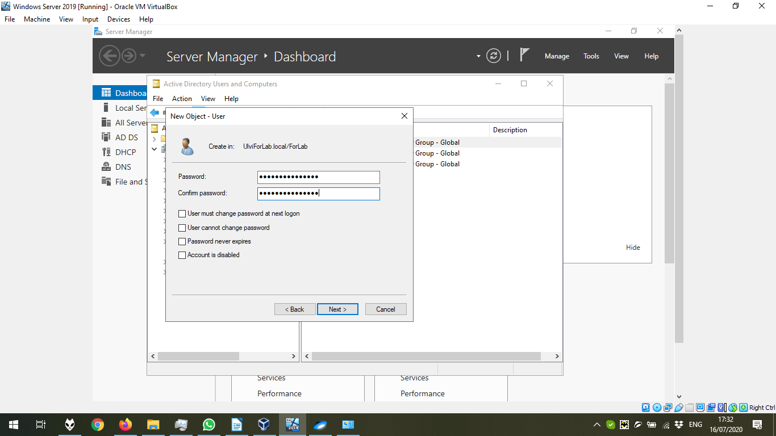

After creating all users (**AccountingUser, FacultyUser, StudentUser**):

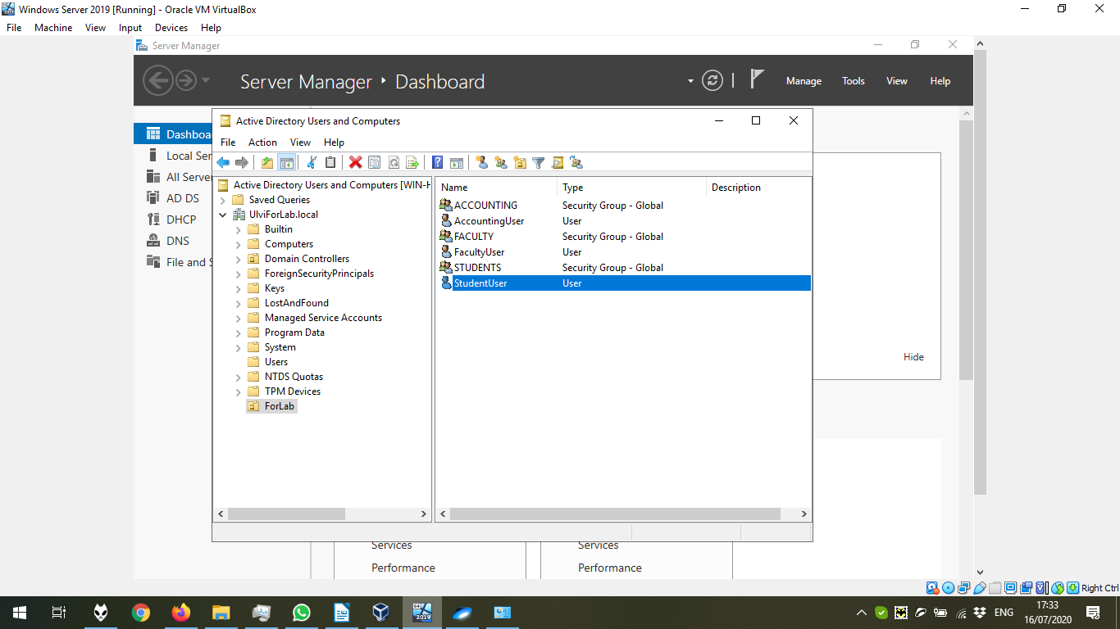

4) Now, let’s add users to the proper groups. First, we get into the properties of the group:

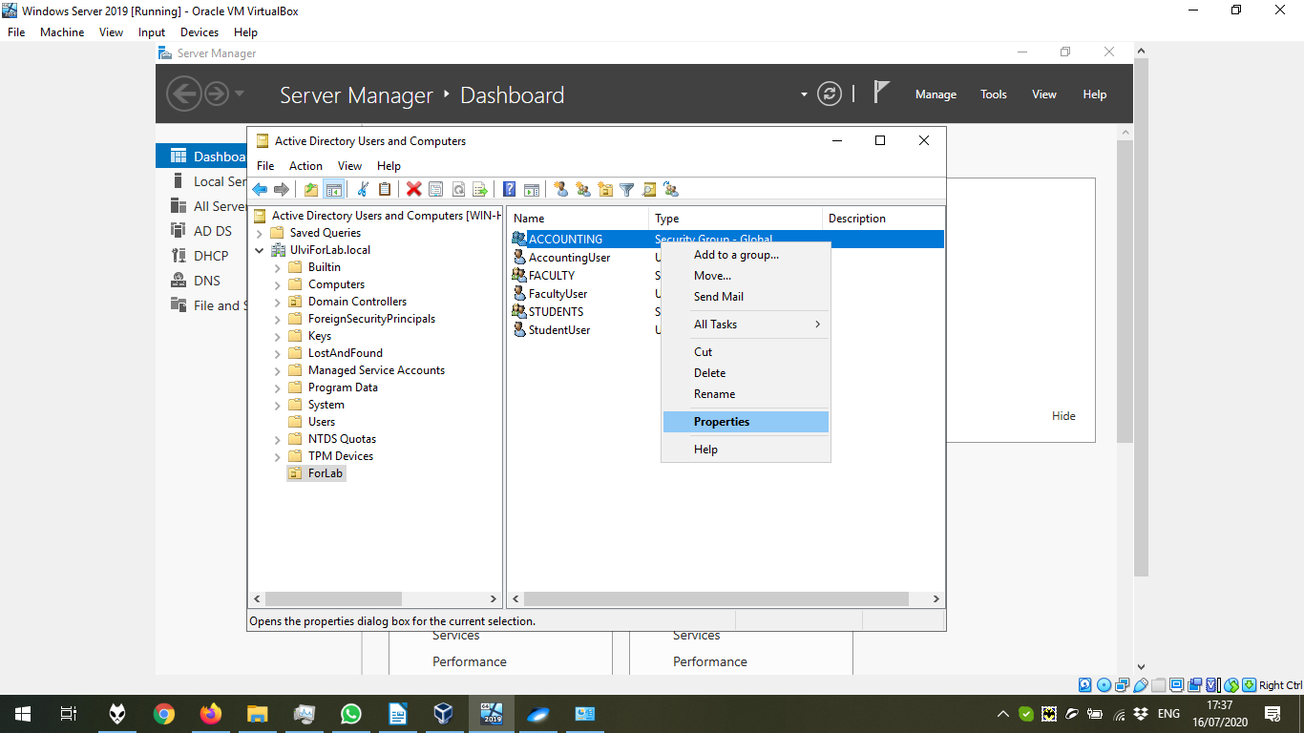

We choose the Members Tab, where we click “Add”:

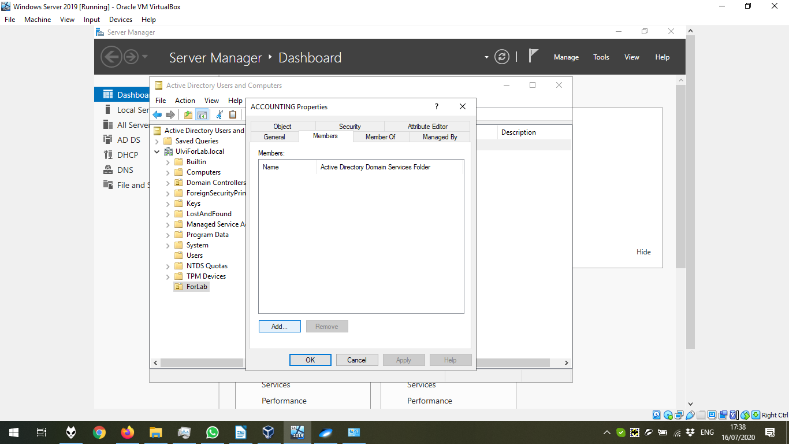

In the window below, we click “Advanced”:

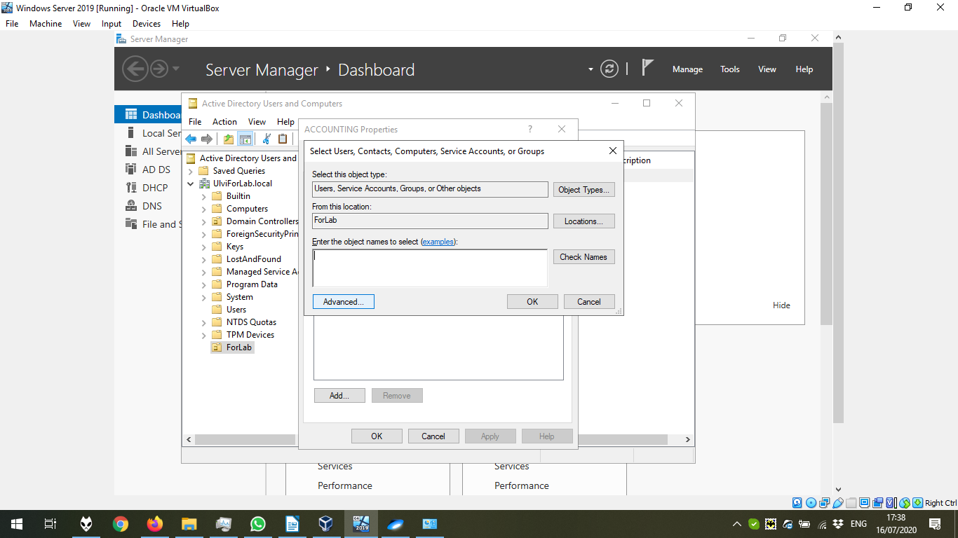

We can click “Find Now” either immediately, or after getting to the location, as in the slide below:

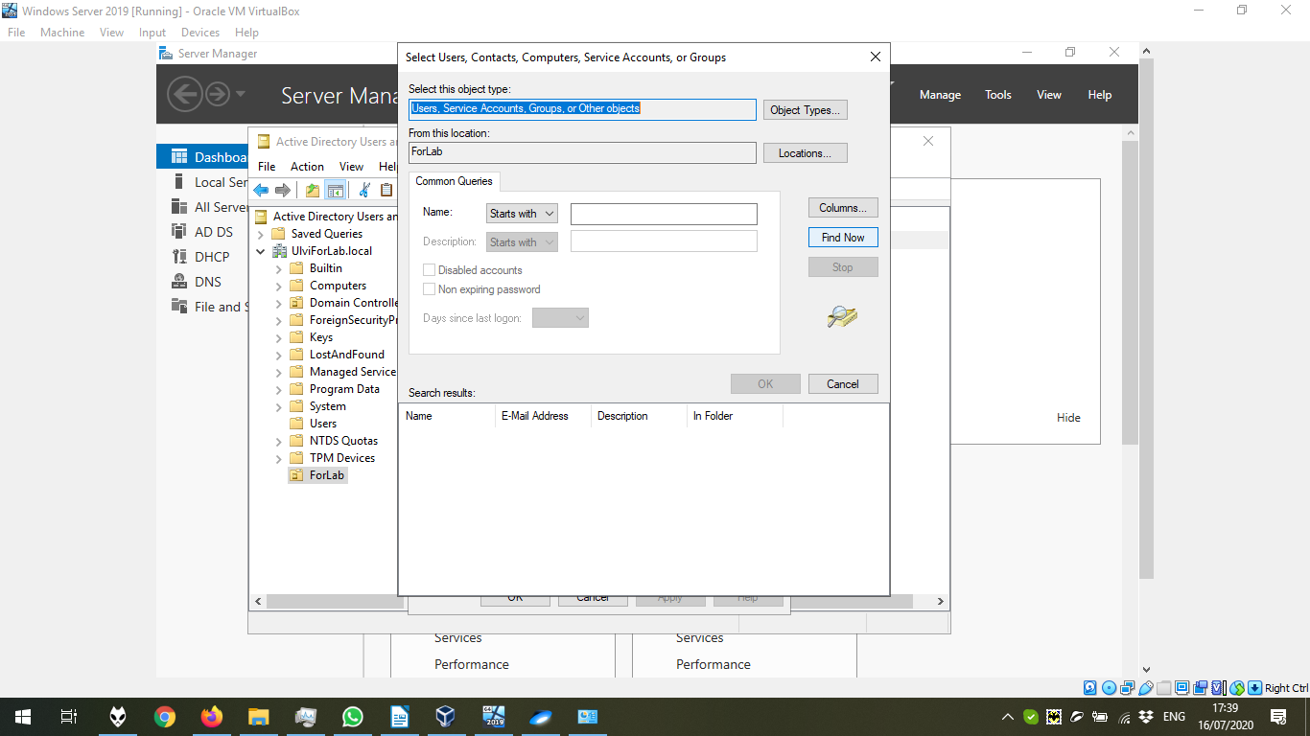

Choose the user and press Enter (Or click OK, which cannot be seen in the slide):

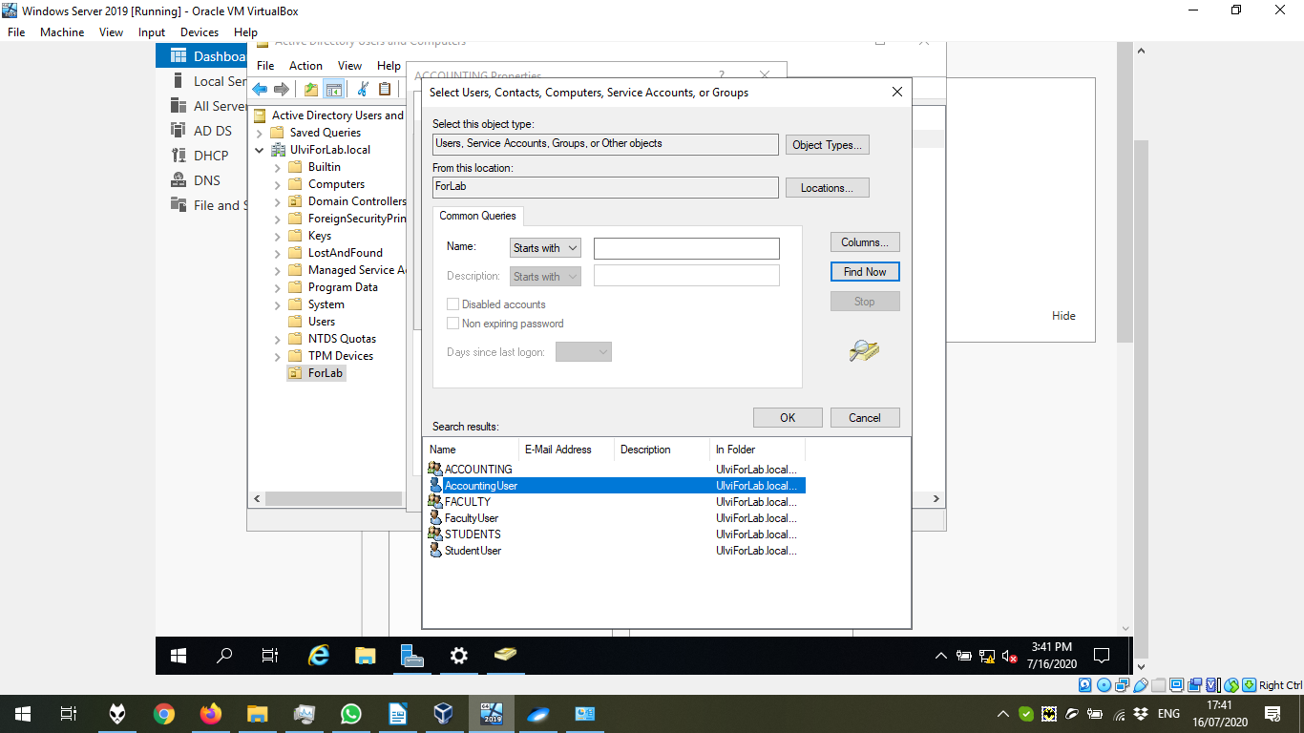

Press OK Button.

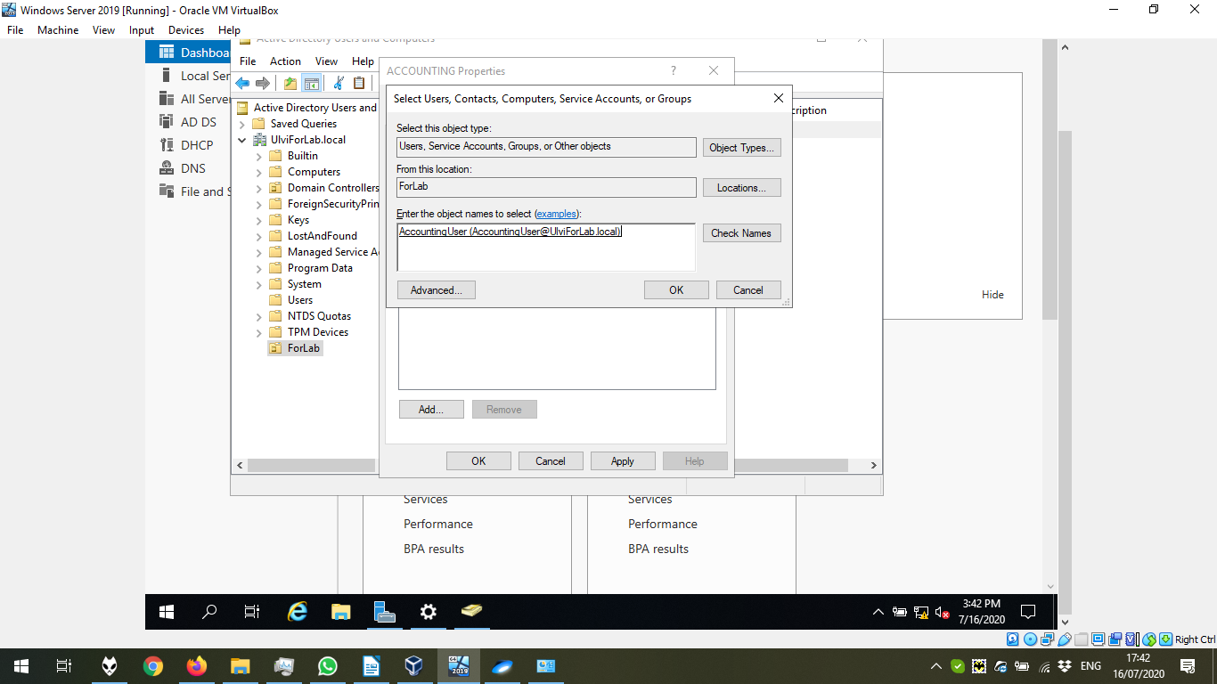

Now, we can click OK. All these steps is done for these users and groups – AccountingUser → ACCOUNTING, FacultyUser → FACULTY, StudentsUser → STUDENTS :

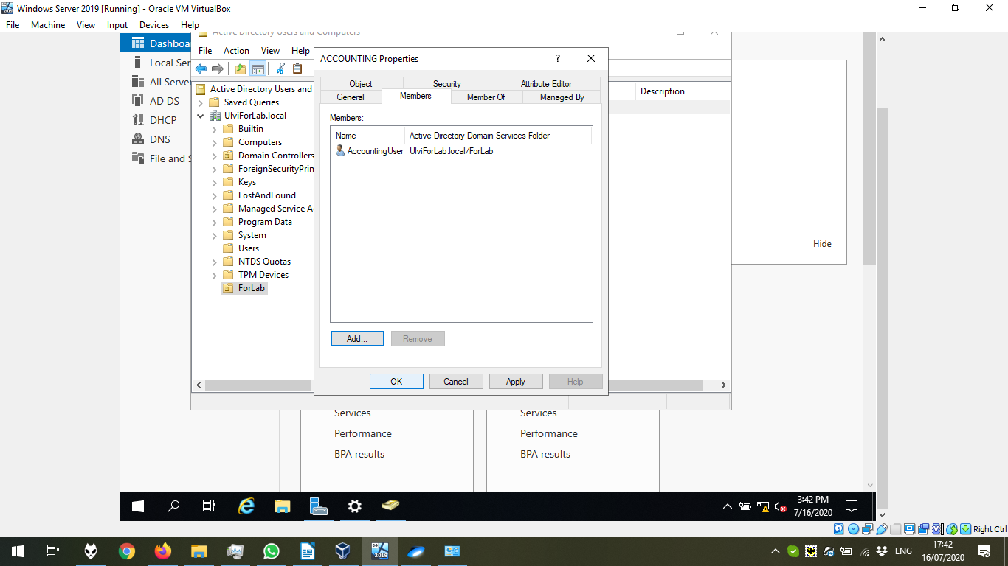

5) Now, we create folders, where we can find the file with name for***GroupName***.txt, with the content “This file should only visible to ***GROUPNAME*** ” :

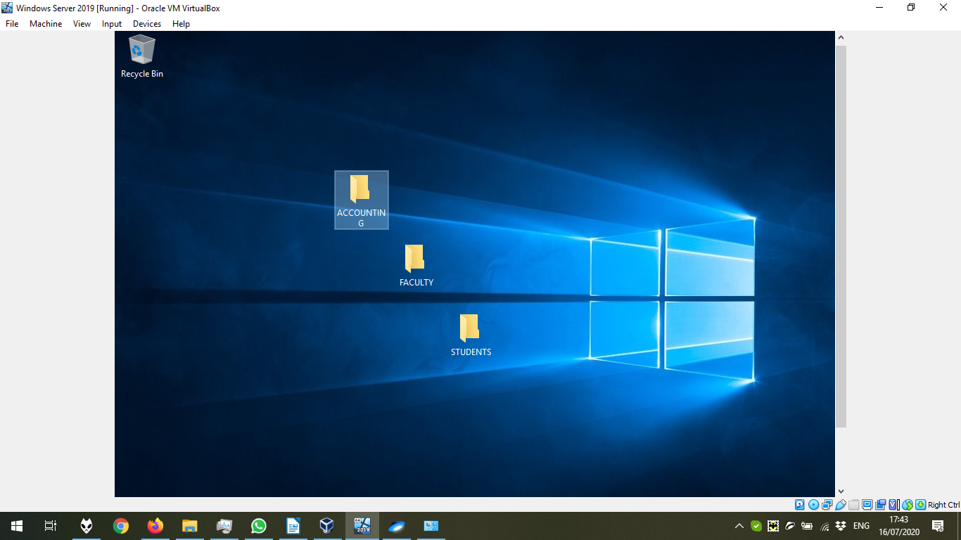

We create the file:

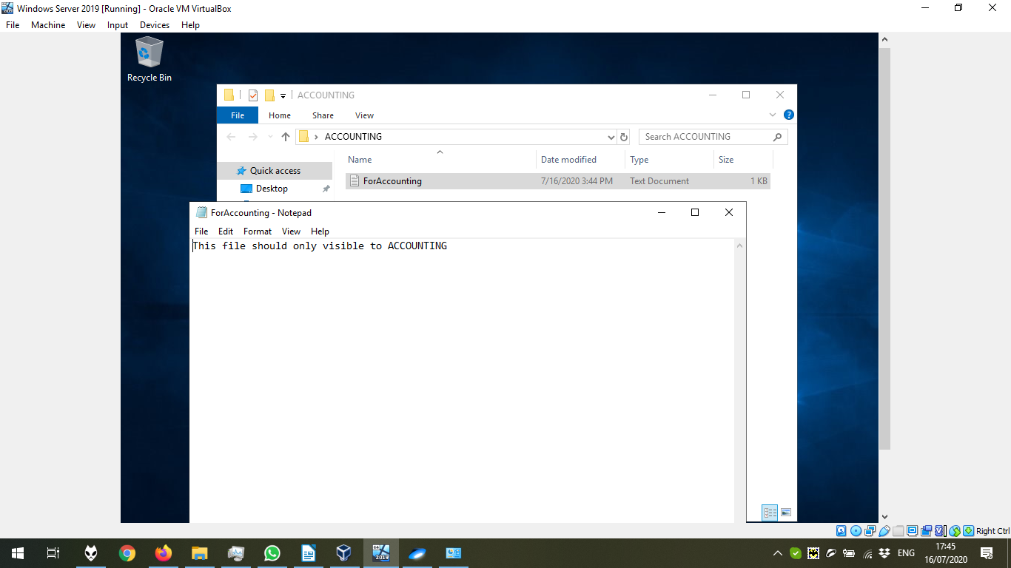

6) Let’s share our files:

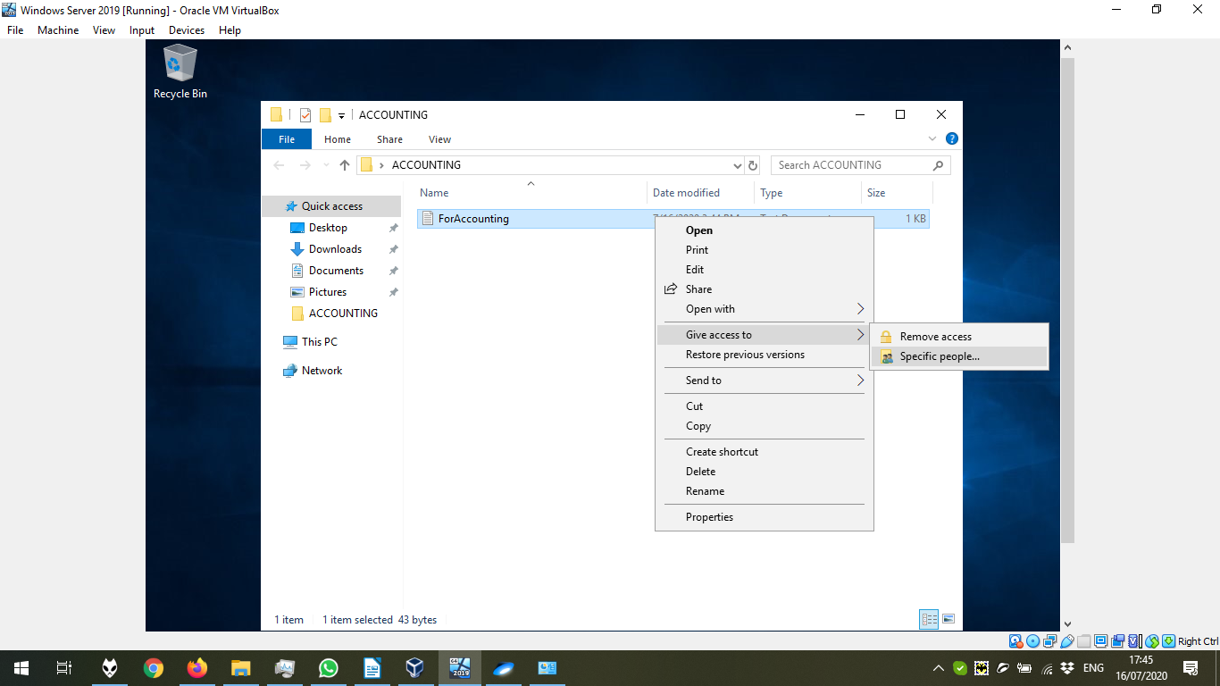

Find people to add:

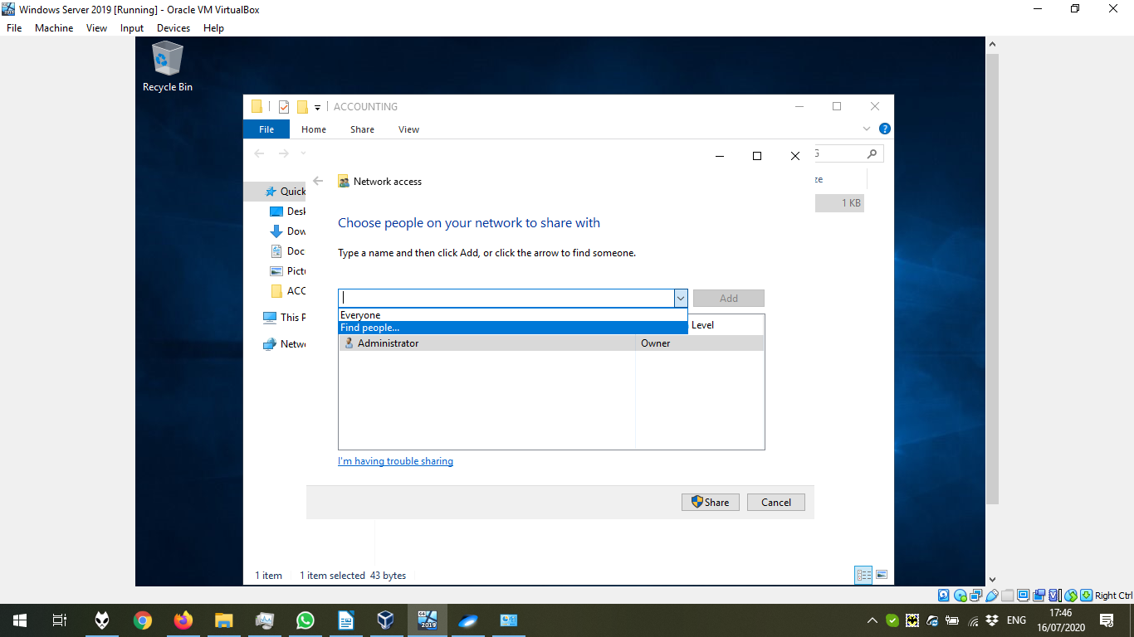

Choose the groups after clicking Find Now:

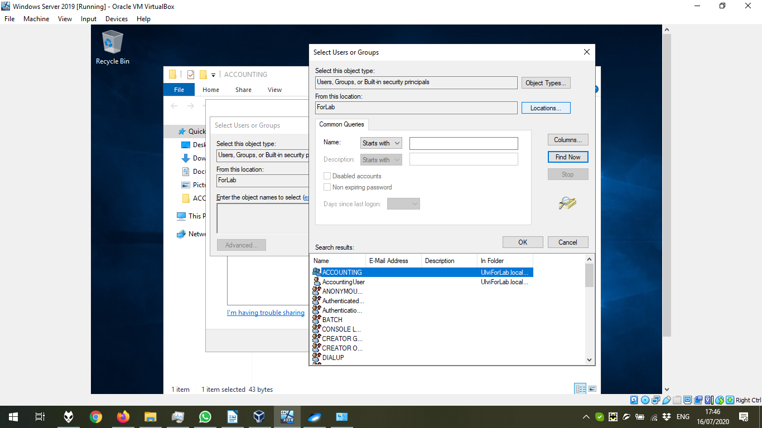

Press OK:

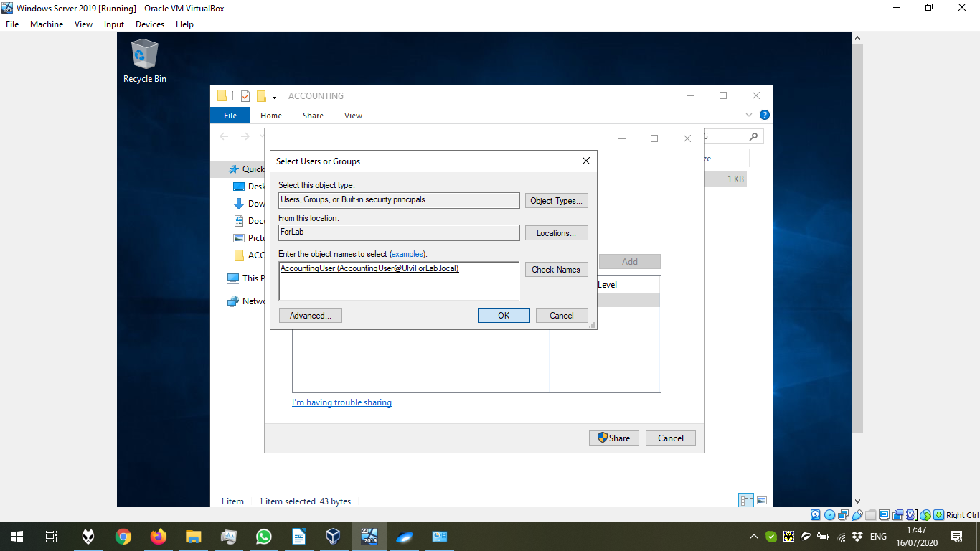

I provided the Read/Write Permission:

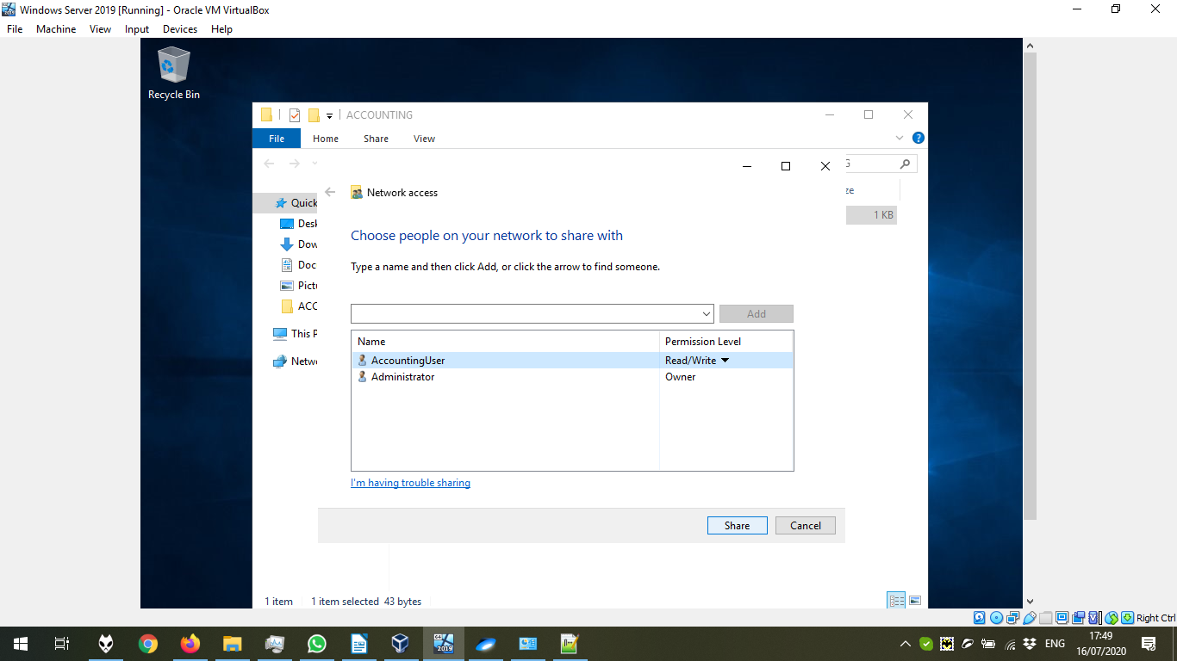

Press Next to provide the Permissions to the folder:

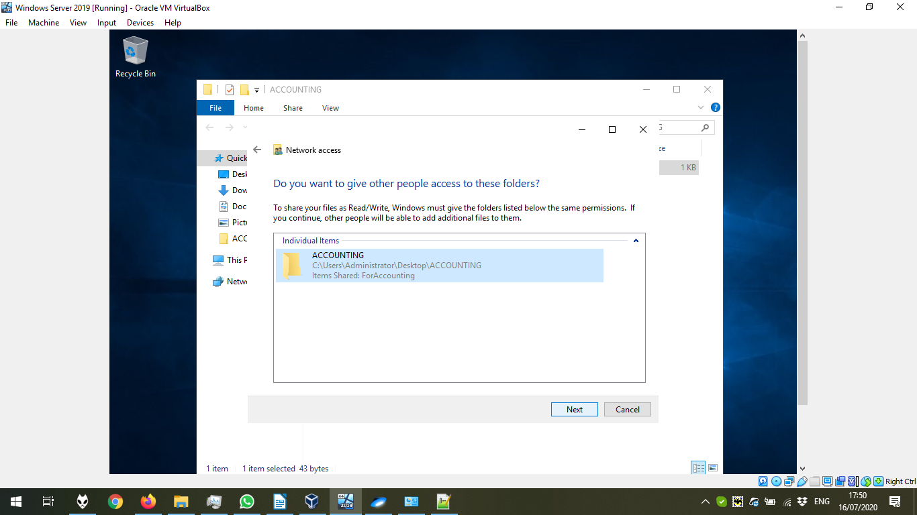

Click done:

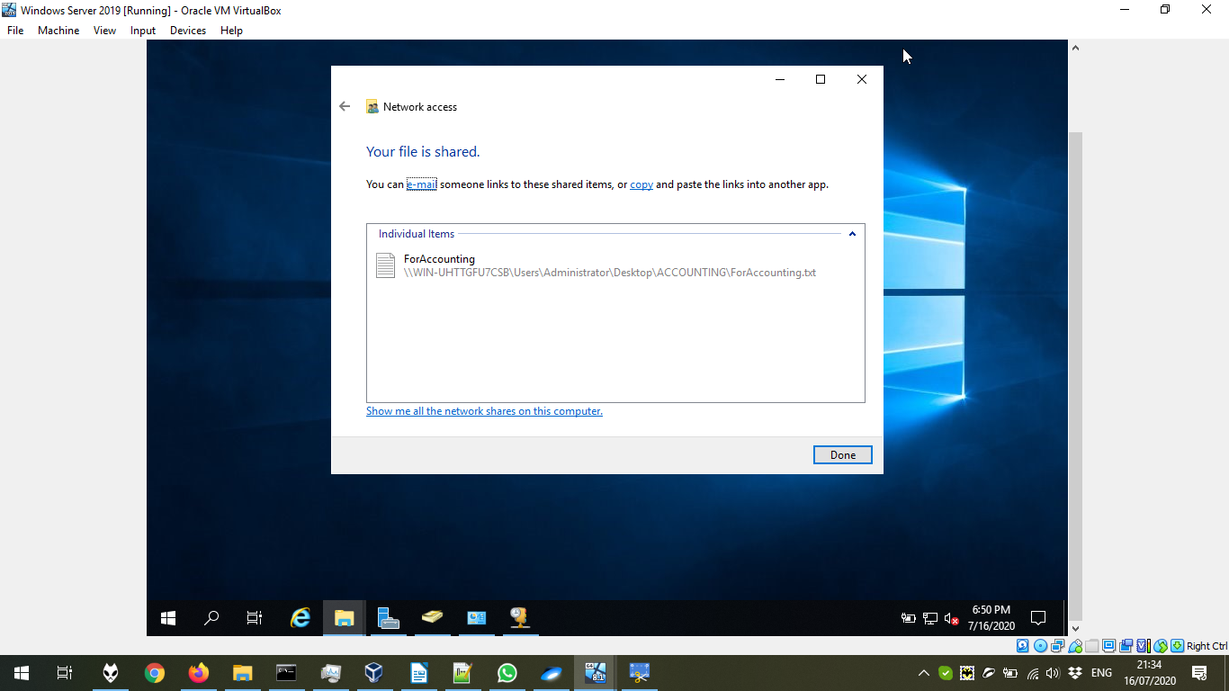

7) Let’s try to get to the user and check. We can enter from Advanced System Properties in This PC:

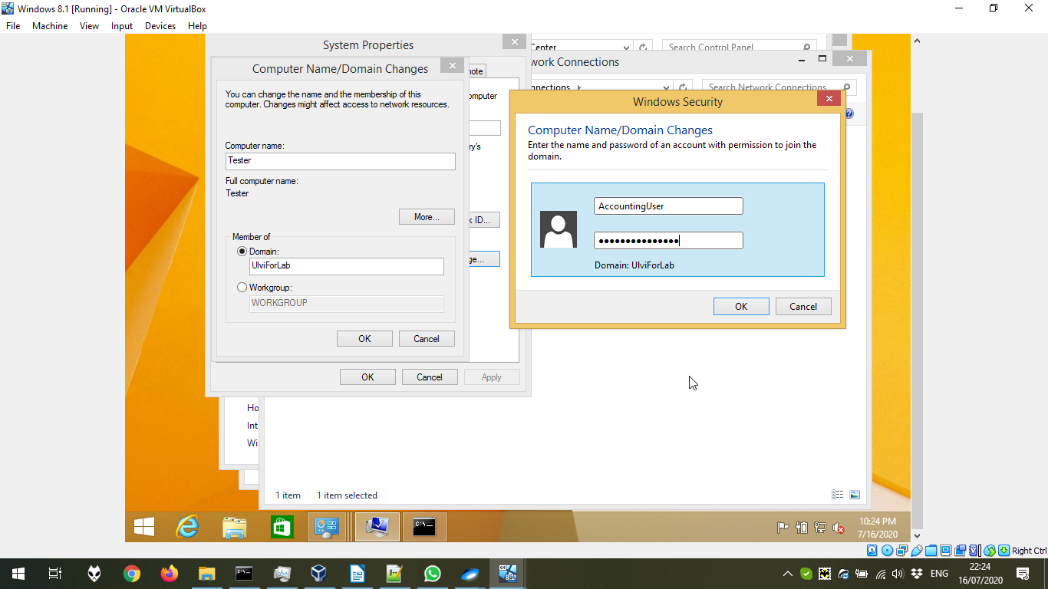

Entered to the domain successfully:

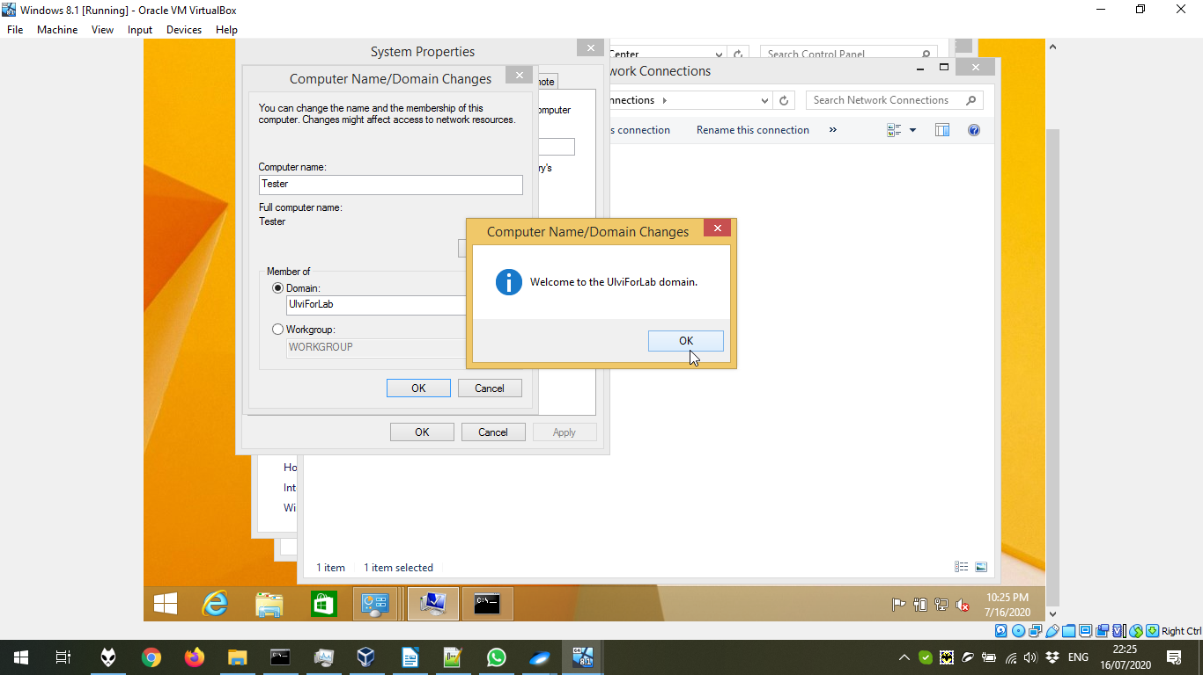

We write our password:

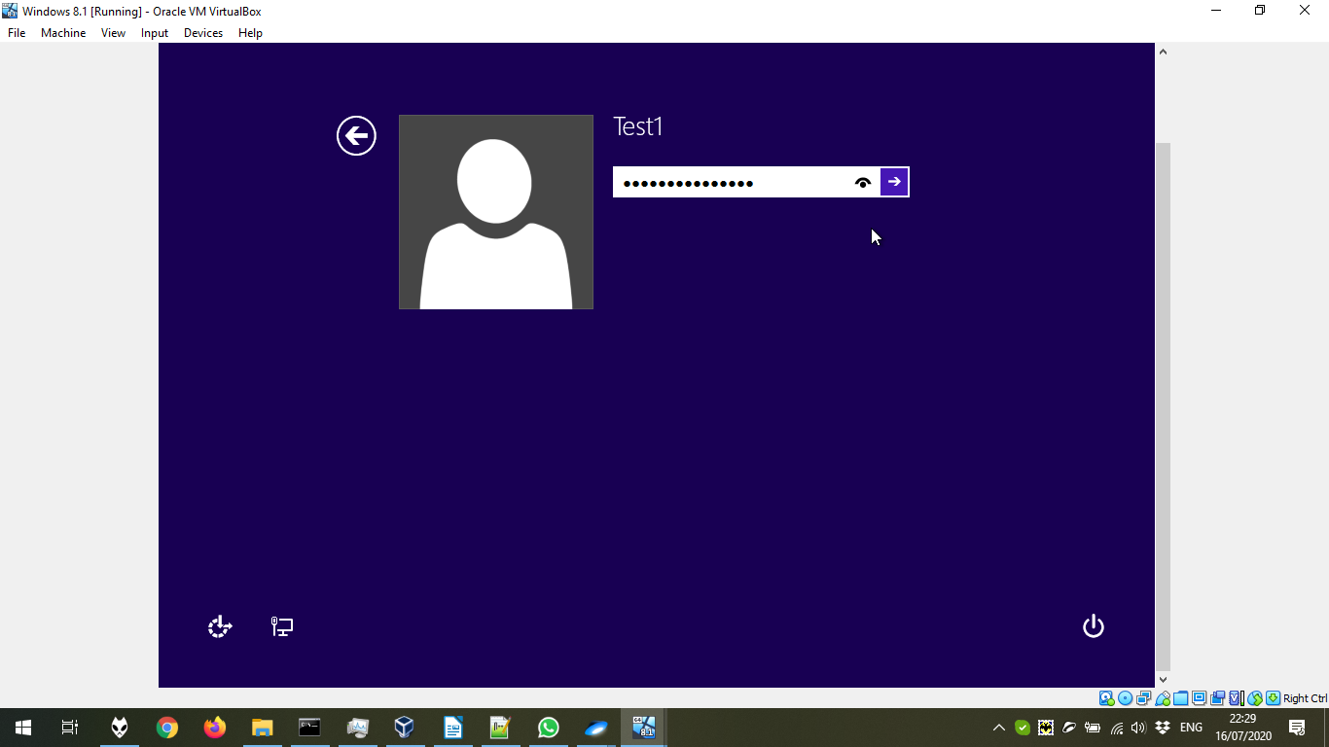

Now, we can find our Network. Remember that both remote connections and file sharing should be turned on in both server and client computers. In the network, we should write our usernames and password. To log out from the network, we log out from the local user and log in again:

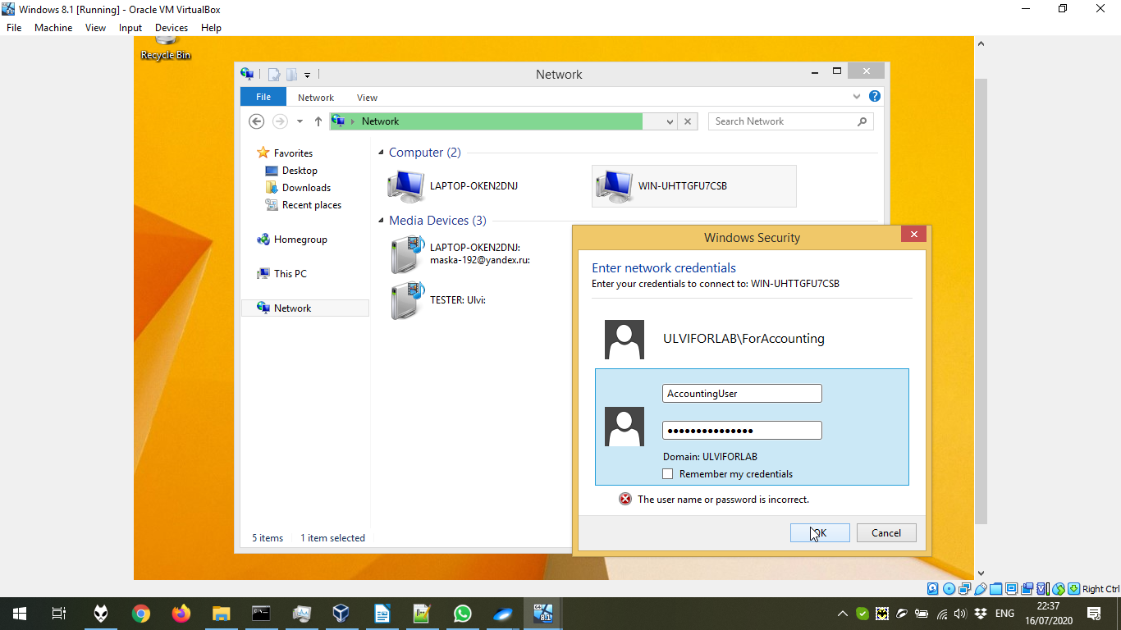

The file in one user is not available for other users. For the user **AccountingUser**:

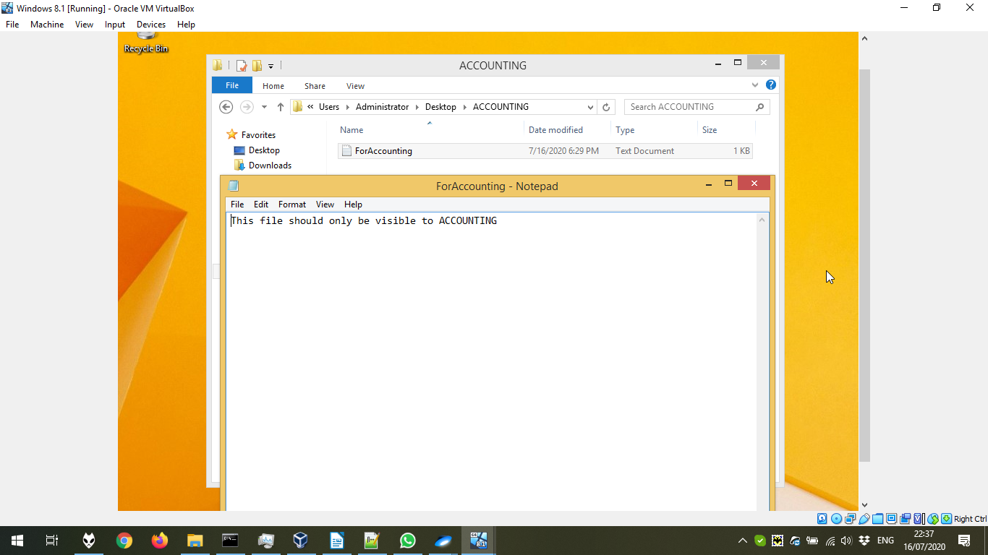

For the user **FacultyUser**:

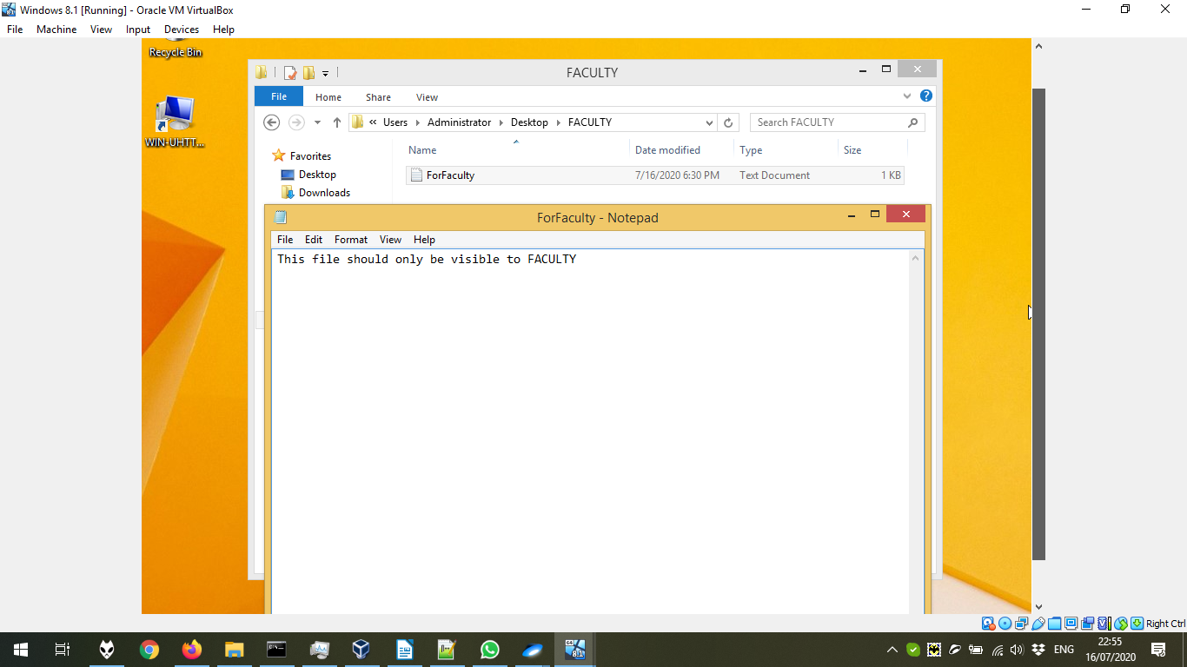

For the user **StudentsUser**:

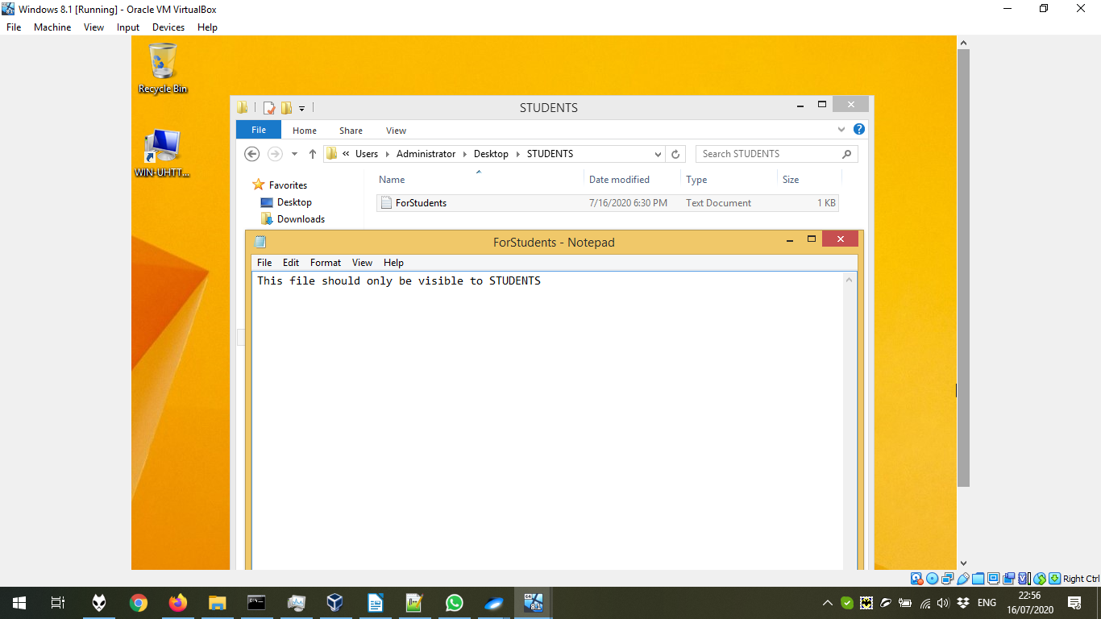

Let’s check if we can access to other folders. The answer is No, because the group doesn’t have the permission:

